- This is one potential solution of many, many solutions. To improve this further, annotate the data flow arrows. Data flow arrows are not supposed to cross over each other… sometimes it is hard though, so just do your best. More information on DFDs straight from the syllabus here: https://digisoln.com/technical_representation/dfd IT IS WORTH A READ!

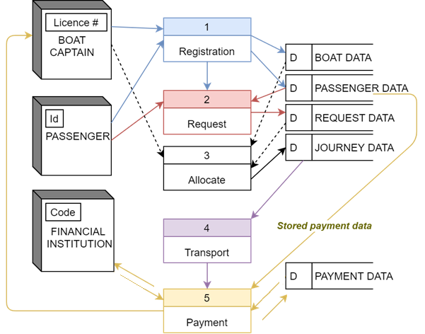

- Pseudocode sample (easier to read if you turn off spell check), assumes:
  - length is pre-defined function that returns count of elements in an array
  - ord and chr to convert from Unicode integers to characters
  - mod as modulo division (remainder division)

BEGIN
INPUT plain_text AS ARRAY
INPUT key1 AS ARRAY
INPUT key2 AS ARRAY
VARIABLE cipher_text AS ARRAY
VARIABLE i AS INTEGER
i = 0
WHILE ( i < length(key1) or i < length(key2) )
base26_char = ord(plain_text[i]) - ord("A")
key1_shift = ord(key1[i]) - ord("A")
key2_shift = key2[i]
cipher_num = (base26_char + key1_shift + key2_shift) mod 26
cipher_char = chr( cipher_num + ord("A") )
cipher_text[i] = cipher_char
i = i + 1
END WHILE
END

In Python (FYI):
plain_text = ["Z","E","B","R","A"]
key1 = ["A","B","B","B","A"]
key2 = [1,2,1,2,1]
cipher_text = []

i = 0
while i < len(key1): #or key2:
base26_char = ord(plain_text[i]) - ord("A")
key1_shift = ord(key1[i]) - ord("A")
key2_shift = key2[i]
cipher_num = (base26_char + key1_shift + key2_shift) % 26
cipher_char = chr(cipher_num+ord("A"))
cipher_text.append(cipher_char)
i=i+1
print(cipher_text)

If ["A", "I", "B"] generates ["W", "I", "Z"], then this is a total shift of [4, 0, 2].
Looking closer at the shift we see the values are (floor) divided by 2:
shift = (base – (key // 2)) mod 26

Given that floor division by 2 is used, the original shift values would have been [8, 0, 4].
key = BASE26(key1[counter])

This statement shows the key was in letters, therefore the original encryption key given would have been the characters representing [8,0,4] which are:
Encryption Key
I | A | E

4.
BEGIN UNICODE_CHARACTER(Base26 integer, Boolean upper):
IF (upper) THEN
RETURN character(integer + ordinal("A"))
ELSE
RETURN character(integer + ordinal("a"))
END IF
END UNICODE_CHARACTER

Extension: BASE26 function without using the keyword ELSE:
BEGIN UNICODE_CHARACTER(Base26 integer, Boolean upper):
IF (upper) THEN
RETURN character(integer + ordinal("A"))
END IF
RETURN character(integer + ordinal("a"))
END UNICODE_CHARACTER

5. The colours are shown:
  - Caesar Shift
  - Polyalphabetic ciphers (e.g. Vigenère and Gronsfeld cipher)
  - One-time Pad
  - Hashing

Plaintext: hi  Pad: abcd  Ciphertext:  hj | Uses a series of interwoven Caesar ciphers based on the letters of a keyword | SHA-256 output will always have a fixed 256-bits length | Only has a maximum of 26 possible key combinations
Weakest of the 4 encryption or hashing techniques listed here | The length of the key guarantees that the ciphertext is not vulnerable due to repetition in the way that the Vigenère cipher is | A key of “N” or 13 will give the same message, whether shifting right or left (ROT13) | If plaintext is longer than the cipher key, wrap back in the key and reuse the letters of the key in order
taking an input string of any length and giving out an output of a fixed length | Monoalphabetic: cipher uses fixed substitution over the entire message | Provided the key is kept secret and never reused, this is the strongest form of encryption here, given its true randomness | A salt is random data that is used as an additional input to a one-way function, to defend against pre-computed hash matching
Identical to Vigenère cipher, except numbers are used as the key instead of letters | Used historically by KGB officers | one-way cryptographic algorithm | Plaintext: abcd  Key: bc  Ciphertext:  bddf

6.
Output is ['x', 'y', 'x', 'y', 'x'], which is useful to wrap key in Vigenère (would work for Gronsfeld too).

In Python (FYI):
def KEYWRAP(plaintext, key):
index = 0
counter = len(key)
while counter < len(plaintext):
value = key[index]
key.append(value) #key[counter] = value
if index < len(key):
index = index + 1
else:
index = 0
#END IF
counter = counter + 1
#END WHILE
return key
#END KEYWRAP

key = ["x","y"]
plaintext = ["h","e","l","l","o"]
key = KEYWRAP(plaintext, key)
print(key)

7. Note: the extension to this question suggests rewriting the algorithms so that so that they do not have to assume capital letters as plaintext. Use answer to question 4 if you want to do this. You could further modify for spaces and punctuation; however it must be stressed maintaining plain text patterns in encryption is a bad idea for security.

Analysing the main difference between the 4:
Caesar: the shift amount is constant (equivalent to a key of [3, 3, 3, 3, 3, ... ] )
Caesar
CONSTANT key = 3

Gronsfeld: the key is an array of variable integers, which wraps repeatedly the length of the plain text message:
Gronsfeld
INPUT key1 as Array
key1 = KEYWRAP(plaintext, key1)
...
key = key1[counter]

Vigenère: same as Gronsfeld (i.e. key wraps length of message), but key is letters:
Vigenère
key = BASE26(key1[counter])

One-time Pad: Key will always be longer than message, so no need to wrap:
One-time Pad
INPUT key1 as Array

8. I only did some of the harder queries, hopefully you are OK with the rest:
Query XVIII:
SELECT COUNT(*), category
FROM books
WHERE title LIKE "%the%" OR title LIKE "%The%"
GROUP BY category
Query IX, X, XI, XII, XIII:
SELECT COUNT(*), AVG(price), category
FROM books
WHERE price < 20
GROUP BY category
HAVING AVG(price) > 16 AND NOT(COUNT(*)==1)
ORDER BY AVG(price) DESC
Query XIV, XV:
SELECT title, category, price
FROM books
WHERE price > (
SELECT price
FROM books
WHERE title == "New Moon"
)
ORDER BY price DESC, category ASC
Statements executed in order: | What does this SQL do?
CREATE TABLE 'sales' (  'book_num' INTEGER,  'cust_email' INTEGER,  PRIMARY KEY('book_num','cust_email')  ); | Creates table sales with composite primary key (i.e. the combination of book_num and cust_email will uniquely identify any row)
SELECT sales.cust_email, books.title  FROM books INNER JOIN sales  ON books.num == sales.book_num | Gives book titles and emails of purchased books only
SELECT s.cust_email, b.title  FROM books b LEFT JOIN sales s  ON b.num == s.book_num | Gives all book titles (even the ones that weren’t purchased) and the emails of customers that purchased those books

9. see answer to question 7 about patterns. Patterns make it more obvious what you are trying to hide.

10. Explain the following algorithmic terms using the samples provided:
Sample | Criteria  Terms | Explanation
BEGIN module1  REPEAT  do long process  UNTIL job done  END module1  BEGIN module2  WHILE job not done  do long process  END WHILE  END module2 | Efficiency  Pre-test vs Post-test loops | module1 post-test happens minimum ONCE  module2 happens minimum of ZERO times (pre-test)  If long process is already done before module launch, it should be avoided. This one more efficient in this case.
BEGIN  x = INPUT team_scoreA  y = INPUT team_scoreB  winner1(x,y)  winner2(x,y)  END  BEGIN winner1(a,b)  IF a > b THEN  PRINT "Winner Team A"  ELSE  PRINT "Winner Team B"  END IF  END  BEGIN winner2(a,b)  IF a == b THEN  PRINT "Teams are drawn"  ELSE  IF a > b THEN  PRINT "Winner Team A"  ELSE  PRINT "Winner Team B"  END IF  END IF  END | Accuracy  Modularity  Selection - Multiple branches  Global vs Local variables | winner1 does not account for draw, and incorrectly would reward Team B as winner in a draw.  winner2 accounts for draw  Therefore, winner2 more accurate algorithm in this case.  Modularity shown with both winner functions. Assuming x and y global (from main algorithm), a and b local to modules (these are passed in as parameters to the function calls). This means value of a in module1 cannot be accessed by module2. Values in x and y can (likely) be accessed in both modules, although better practise (perhaps) would be to label these GLOBAL.

